Use ai_jobs;

Select * from ai_job_dataset;

-- QUERY 1: Basic salary statistics

-- Purpose: Get overall salary information

SELECT COUNT(*) as total_jobs,

AVG(salary_usd) as average_salary,

MIN(salary_usd) as minimum_salary,

MAX(salary_usd) as maximum_salary

FROM ai_job_dataset

WHERE salary_usd IS NOT NULL;

-- What this shows: Overall job market statistics

-- Why useful: Gives context for individual salaries

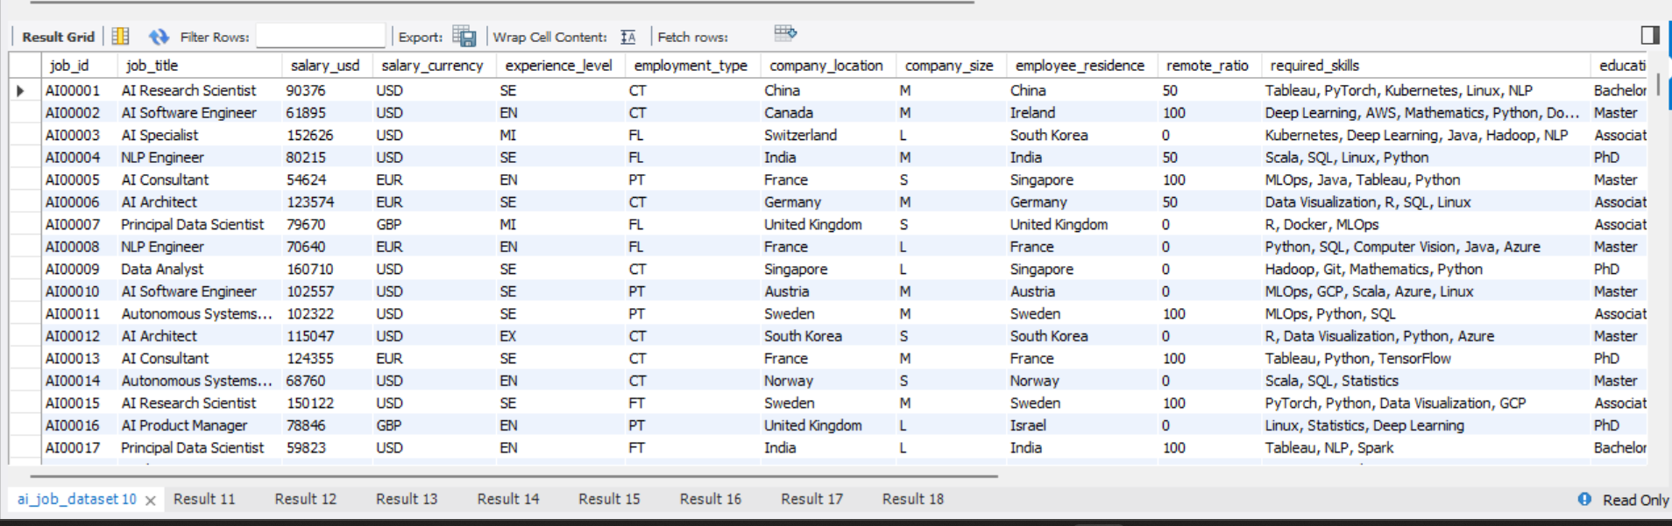

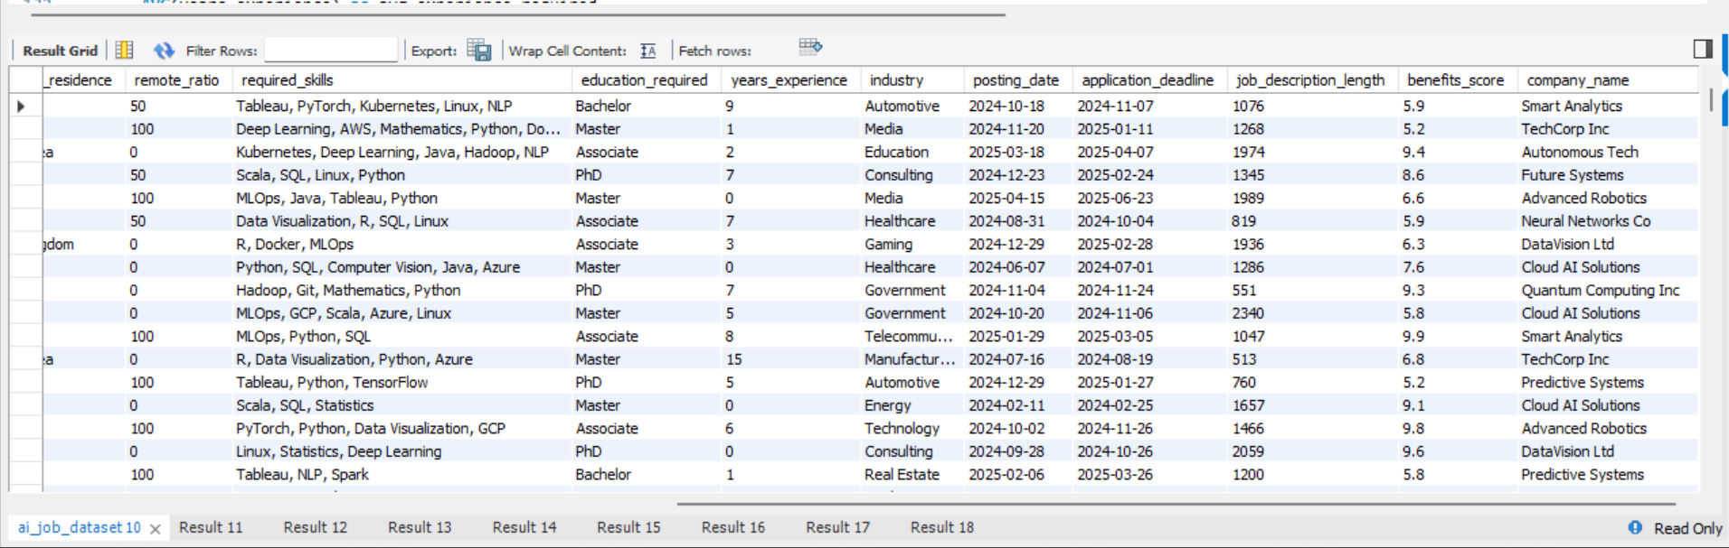

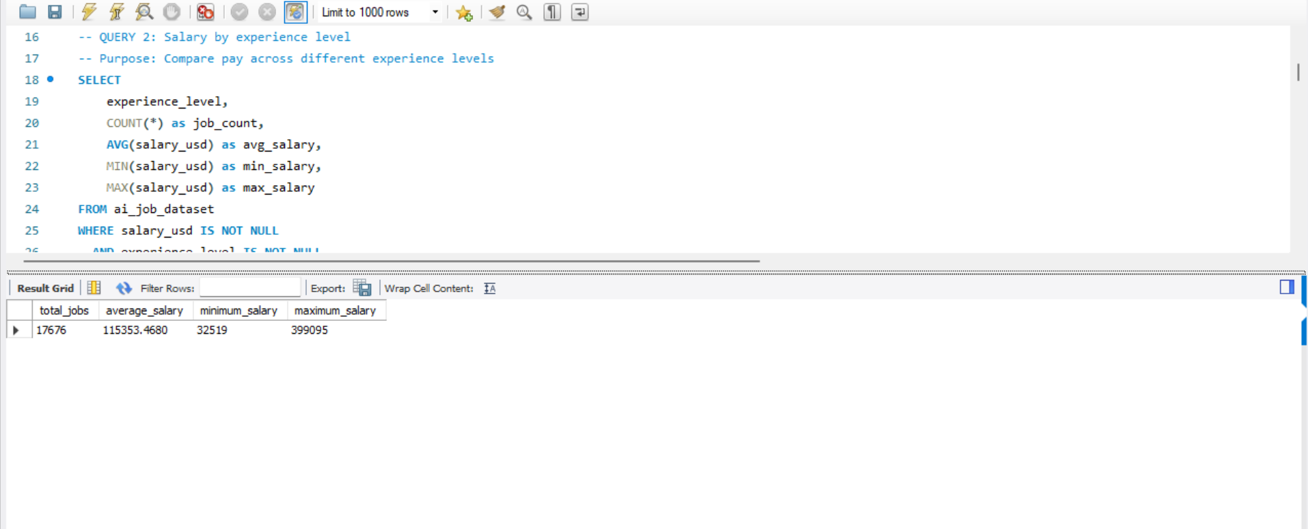

-- QUERY 2: Salary by experience level

-- Purpose: Compare pay across different experience levels

SELECT

experience_level,

COUNT(*) as job_count,

AVG(salary_usd) as avg_salary,

MIN(salary_usd) as min_salary,

MAX(salary_usd) as max_salary

FROM ai_job_dataset

WHERE salary_usd IS NOT NULL

AND experience_level IS NOT NULL

GROUP BY experience_level

ORDER BY avg_salary DESC;

-- What this shows: How experience affects salary

-- Why useful: Helps job seekers understand career progression

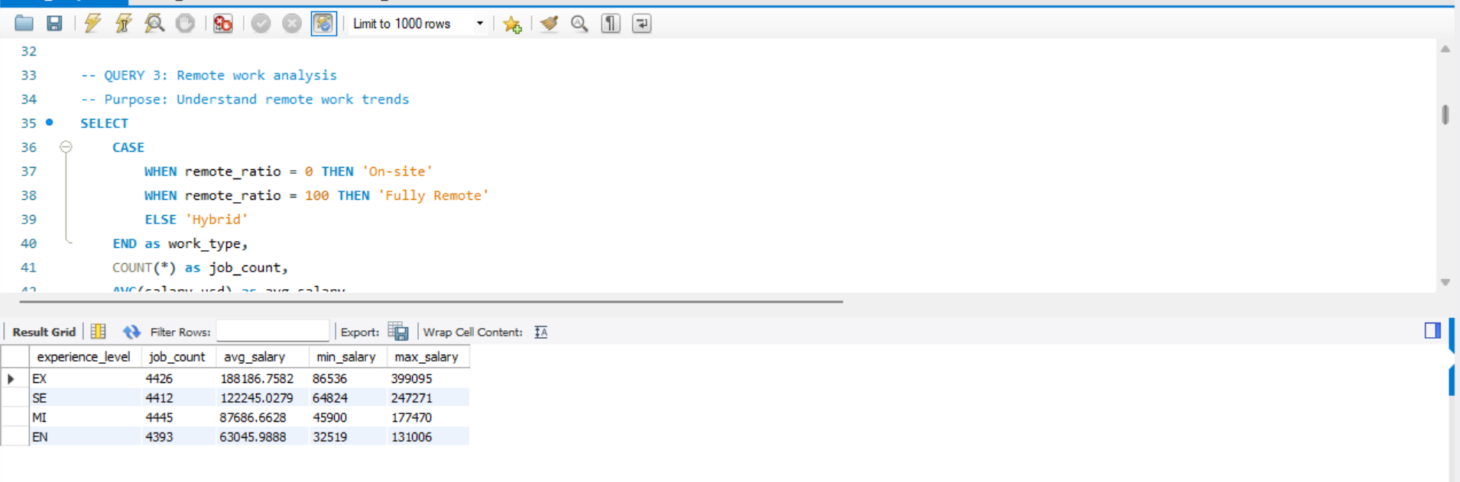

-- QUERY 3: Remote work analysis

-- Purpose: Understand remote work trends

SELECT

CASE

WHEN remote_ratio = 0 THEN 'On-site'

WHEN remote_ratio = 100 THEN 'Fully Remote'

ELSE 'Hybrid'

END as work_type,

COUNT(*) as job_count,

AVG(salary_usd) as avg_salary,

ROUND(COUNT(*) * 100.0 / (SELECT COUNT(*) FROM ai_job_dataset), 2) as percentage

FROM ai_job_dataset

WHERE remote_ratio IS NOT NULL

GROUP BY

CASE

WHEN remote_ratio = 0 THEN 'On-site'

WHEN remote_ratio = 100 THEN 'Fully Remote'

ELSE 'Hybrid'

END

ORDER BY job_count DESC;

-- What this shows: Remote work distribution and pay impact

-- Why useful: Shows if remote work affects salary

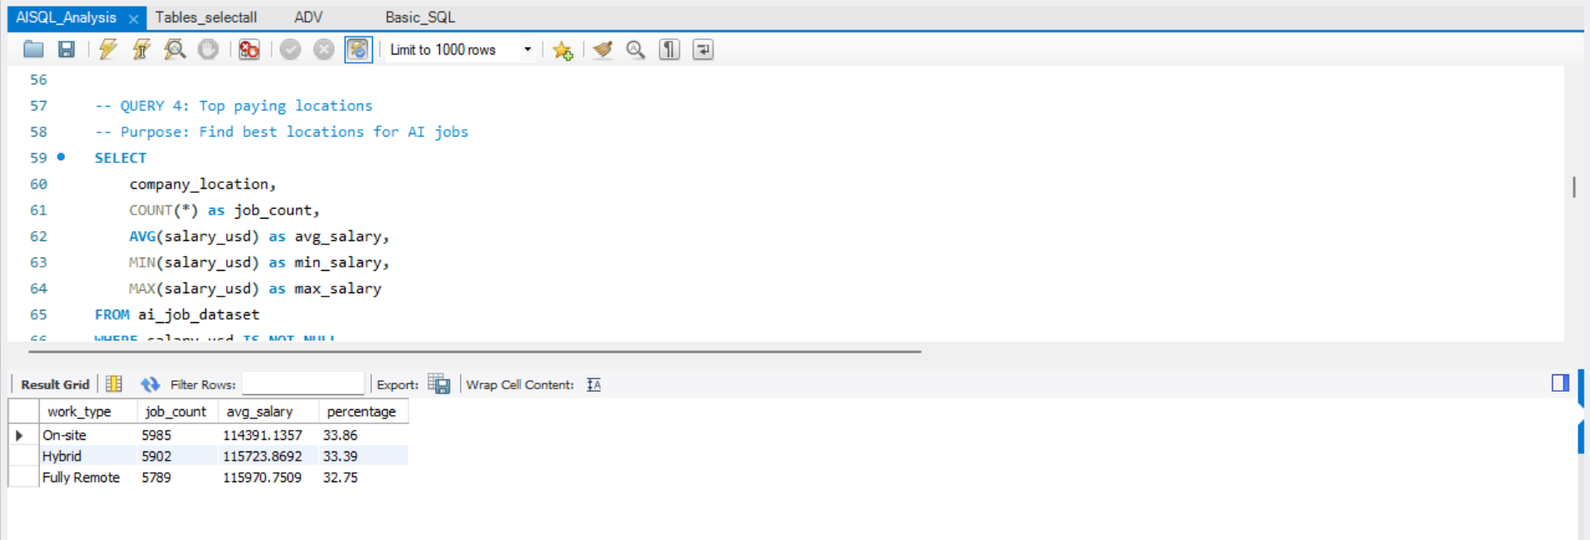

-- QUERY 4: Top paying locations

-- Purpose: Find best locations for AI jobs

SELECT

company_location,

COUNT(*) as job_count,

AVG(salary_usd) as avg_salary,

MIN(salary_usd) as min_salary,

MAX(salary_usd) as max_salary

FROM ai_job_dataset

WHERE salary_usd IS NOT NULL

AND company_location IS NOT NULL

GROUP BY company_location

HAVING COUNT(*) >= 5 -- Only locations with at least 5 jobs

ORDER BY avg_salary DESC

LIMIT 10;

-- What this shows: Which locations pay the most

-- Why useful: Helps with job search and relocation decisions

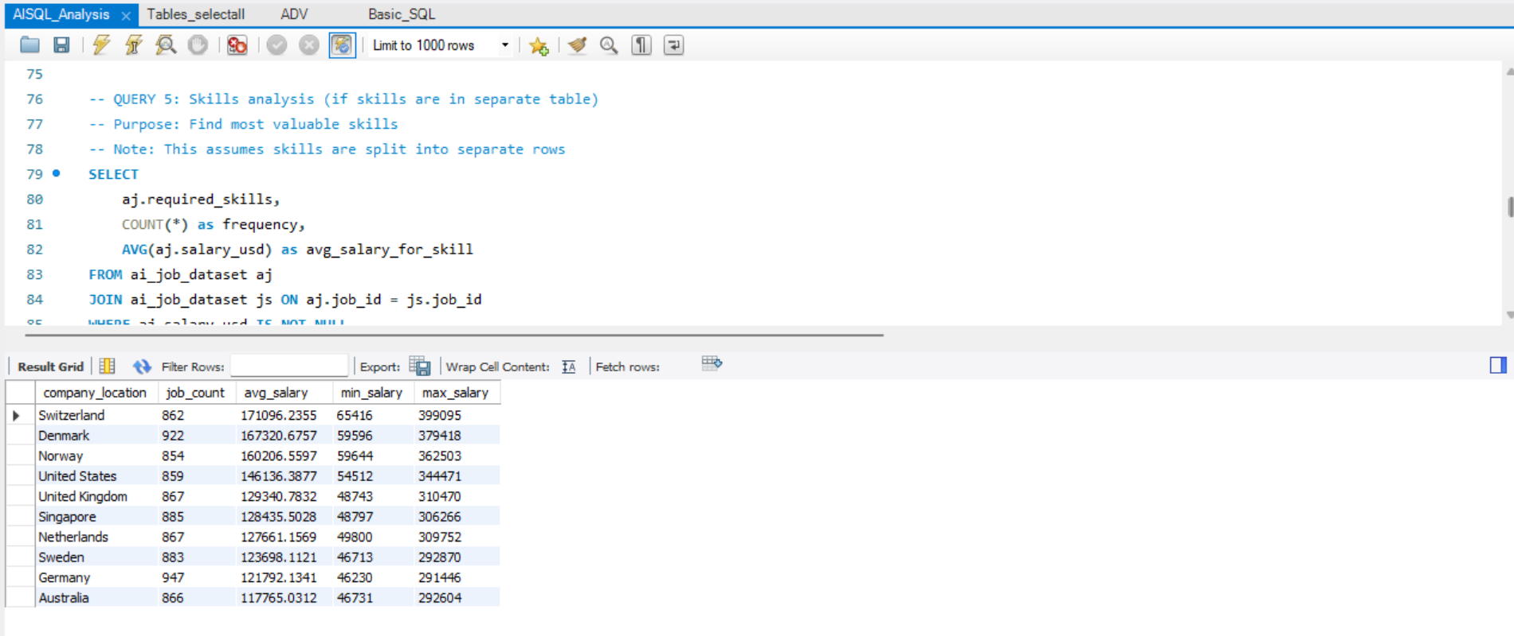

-- QUERY 5: Skills analysis (if skills are in separate table)

-- Purpose: Find most valuable skills

-- Note: This assumes skills are split into separate rows

SELECT

aj.required_skills,

COUNT(*) as frequency,

AVG(aj.salary_usd) as avg_salary_for_skill

FROM ai_job_dataset aj

JOIN ai_job_dataset js ON aj.job_id = js.job_id

WHERE aj.salary_usd IS NOT NULL

GROUP BY aj.required_skills

HAVING COUNT(*) >= 10 -- Skills mentioned in at least 10 jobs

ORDER BY avg_salary_for_skill DESC

LIMIT 15;

-- What this shows: Which skills pay the most

-- Why useful: Guides learning and skill development

-- QUERY 6: Company size impact

-- Purpose: See how company size affects salary and remote work

SELECT

company_size,

COUNT(*) as job_count,

AVG(salary_usd) as avg_salary,

AVG(remote_ratio) as avg_remote_ratio,

COUNT(CASE WHEN remote_ratio = 100 THEN 1 END) as fully_remote_count

FROM ai_job_dataset

WHERE company_size IS NOT NULL

GROUP BY company_size

ORDER BY avg_salary DESC;

-- What this shows: How company size affects pay and remote work

-- Why useful: Helps choose between startup vs large company

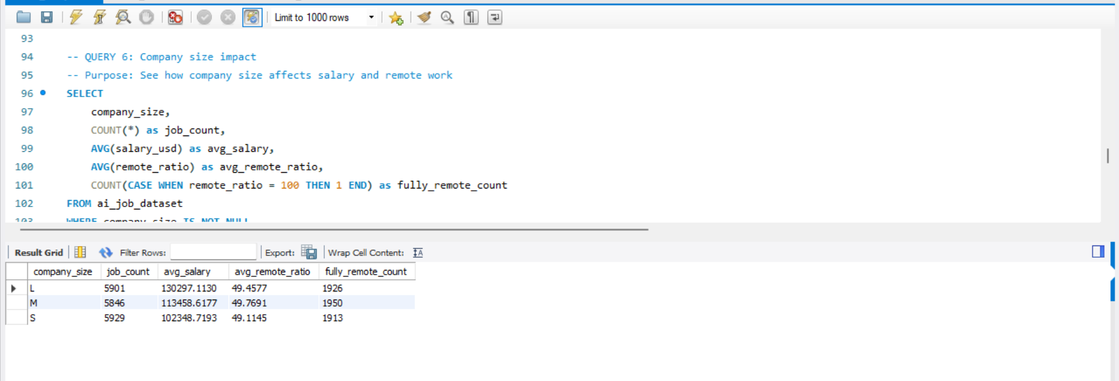

-- QUERY 7: Trending over time

-- Purpose: See how the job market is changing

SELECT

YEAR(posting_date) as posting_year,

MONTH(posting_date) as posting_month,

COUNT(*) as jobs_posted,

AVG(salary_usd) as avg_salary,

AVG(remote_ratio) as avg_remote_ratio

FROM ai_job_dataset

WHERE posting_date >= '2022-01-01' -- Last few years

GROUP BY YEAR(posting_date), MONTH(posting_date)

ORDER BY posting_year, posting_month;

-- What this shows: Job market trends over time

-- Why useful: Shows if market is growing and salary trends

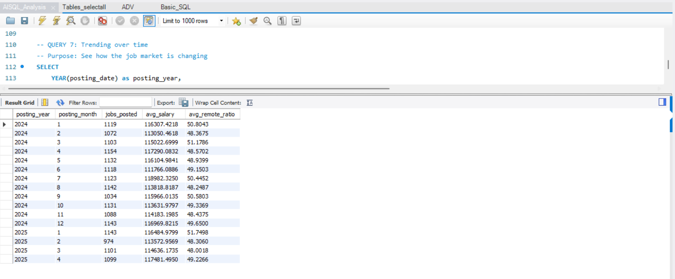

-- QUERY 8: Education requirements vs salary

-- Purpose: See if education affects pay

SELECT

education_required,

COUNT(*) as job_count,

AVG(salary_usd) as avg_salary,

AVG(years_experience) as avg_experience_required

FROM ai_job_dataset

WHERE education_required IS NOT NULL

AND salary_usd IS NOT NULL

GROUP BY education_required

ORDER BY avg_salary DESC;

-- What this shows: How education level affects salary

-- Why useful: Helps understand if advanced degrees are worth it

